Course Project - Perform Analysis using SAS Procedures

Shaun Pritchard

Rasmussen College

QMB4200

Terry Brookhouser

October 30, 2020

Course Project - Perform Analysis using SAS Procedures

In this lesson I used several scripts to calculate and run statistics:

* Step 1: Create a SAS script and read the data from the SQL Table(FinalProjectDataSet.csv)
* Step 2: Use SAS proc methods and calculate number of crime incidents per zip code, mean score, Std Dev
* Step 3: Determine the police officer count based on the following the logic.

For this I used 2 scripts because I was not sure if I was supposed to use the Zip code data and calculate the frequency of duplicates where crimes occurred to apply the statistics and calculate the police officer count. So, I followed the example in class. I also imported the data set file and ran statistics directly to accumulate the lesson parameters.

**Script 1** – My custom Script

**Script 2** - Custom scripts based off in class example

**Script 1 – Code:**

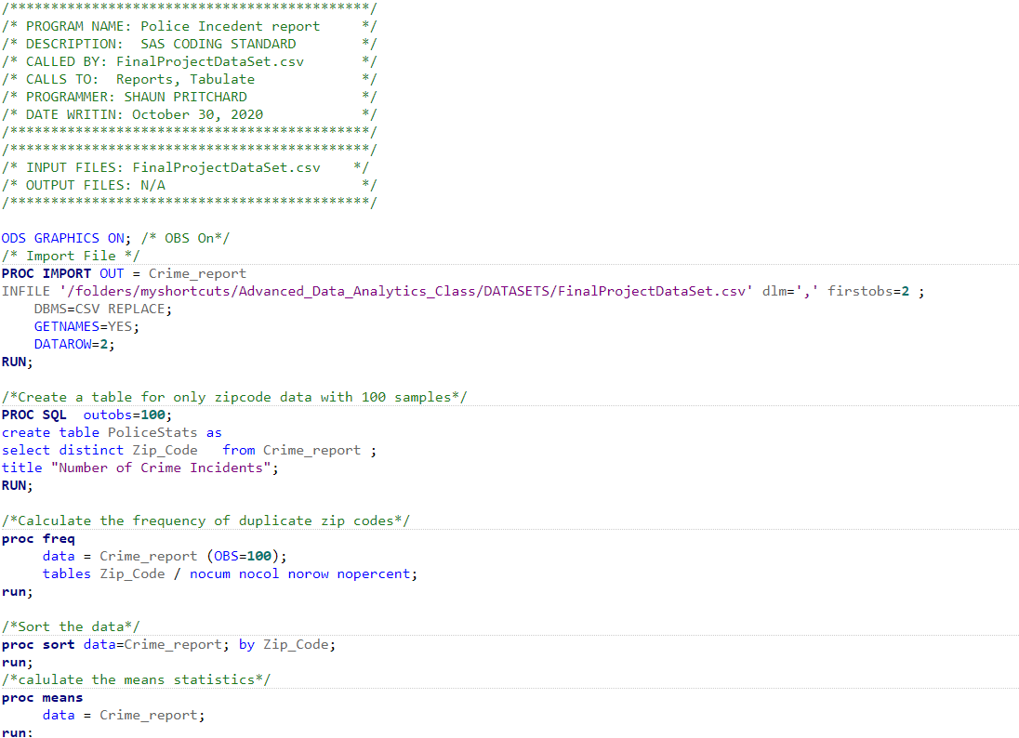 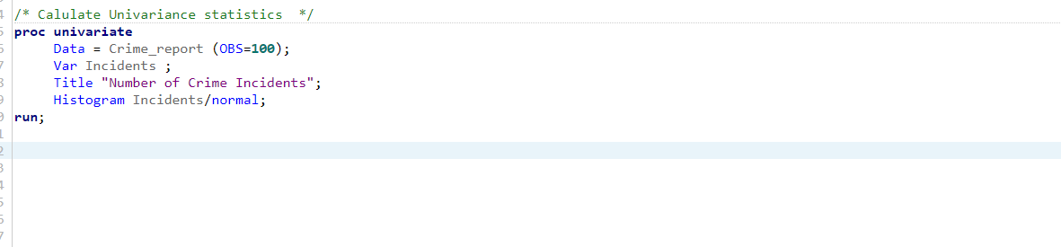

**Script 1 – Output:**



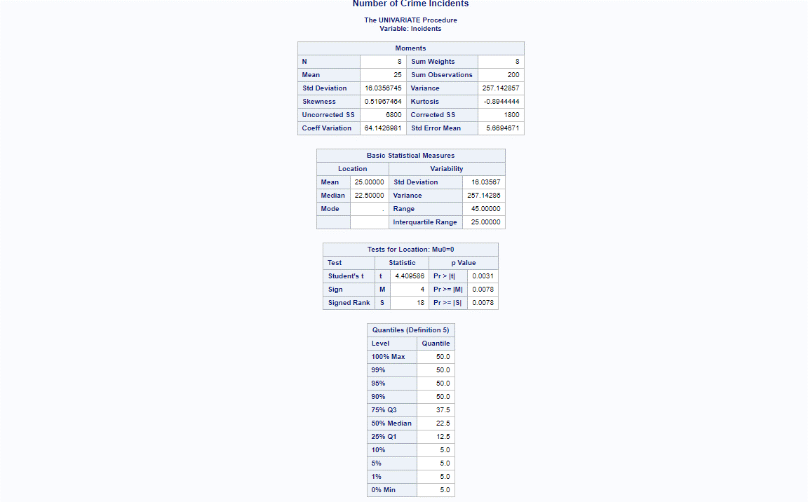

**Script 2 – Code:**

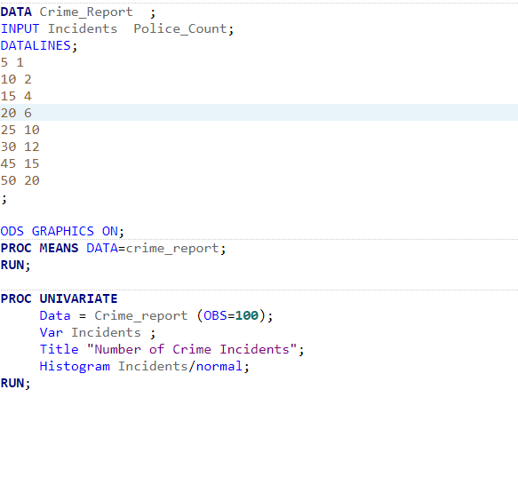

**Script 2 – Output:**

